Blossom & Create configuration

Author: Asaf Shochet

Last revision: 27/01/2015

Contents

Intro 1

Create configurations 1

New account configuration on Create 1

Getting the secret key for SSO & publish to blossom 2

Configure publishing options 4

Blossom configurations 4

SSO configurations 4

Publish configurations 5

Troubleshooting 7

Errors in SSO 7

Errors in publish 8

## Intro

This document describes the configuration that needs to be done on both Create and Blossom platforms in order to perform SSO from Blossom to Create, and publish from Create to Blossom.

SSO (Single Sign On) - In a typical SSO scenario a user which is logged in to an external application (Blossom) would like to launch the Create application from within that application without the need to authenticate directly to Create.

Publish - When a user enters the Create via SSO from Blossom, he is able to publish a lesson to the Blossom server that he was first got to. After publishing he can see the published lesson on his blossom's content.

## Create configurations

When creating an account in Create, it automatically creates an account ID used in Create (a number, i.e.: 2, 13, 22) and an ID used for external systems like Blossom (a string, i.e. Create-34)

### New account configuration on Create

1. Login with admin credentials

User: admin

Pass: 123456

1. Create a new account

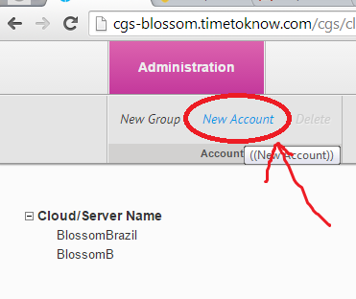

1. Change its name to something meaningful and unique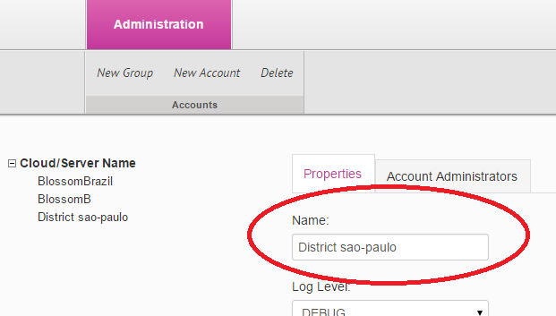

### Getting the secret key for SSO & publish to blossom

Open Robomongo, connect to the Create server and run this query:

db.publishers.find({name:"THE NAME YOU CHOSE EARLIER"})

example:

db.publishers.find({name:"District sao-paulo"})

You'll get a result like this:

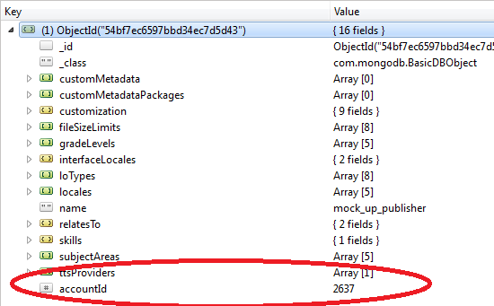

Write the "accountId" on a note, we'll need it in a minute.

Now, run this query, using the account ID

db.externalPartners.find({accountId:ACCOUNT_ID_NUMBER})

Example:

db.externalPartners.find({accountId:2637})

Write aside the externalId, and the secret key, they we'll be used for blossom integration.

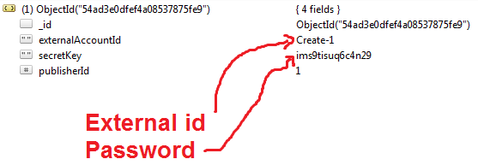

### Configure publishing settings

Login to CGS with the account admin user password

Go to settings -> publish settings

Check the following boxes to enable blossom publishing

Make sure you disable the publish course options

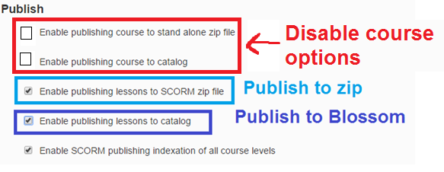

## Blossom configurations

Login to blossom with account admin for the specific region (i.e. t2kadmin)

### SSO configurations

Go to "management" -> Domain management -> Manage providers

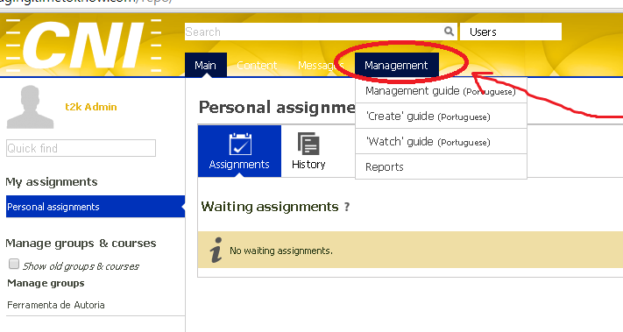

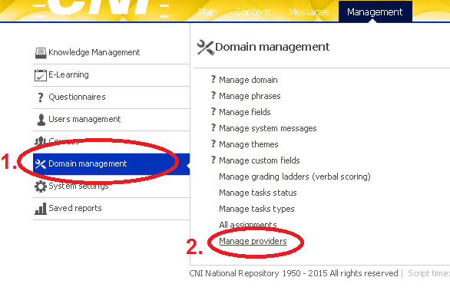

Enter the Create domain, account's external Id and account's secret key.

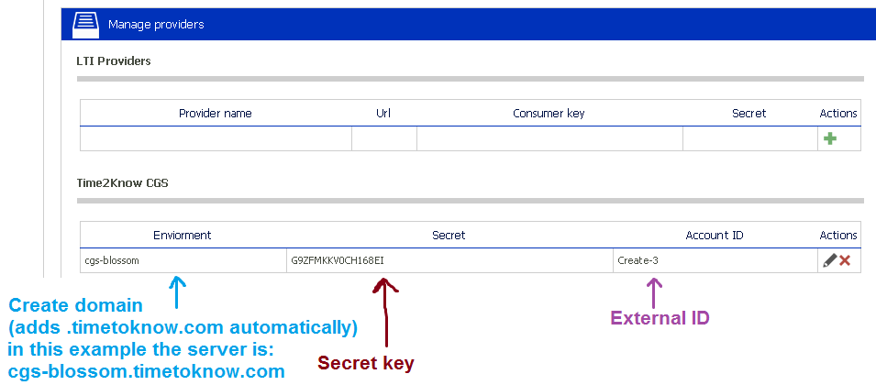

### 

### Publish configurations

Go to management -> system settings -> Server configuration -> APIs -> "Content upload api" section



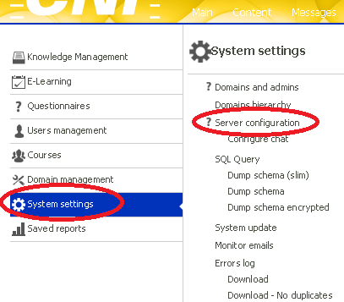

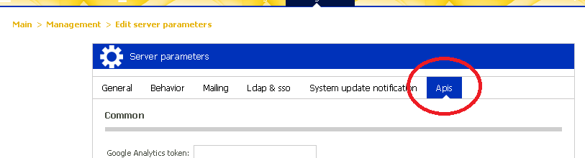

Scroll down to Content upload api, and enter the account ID and secret key as following

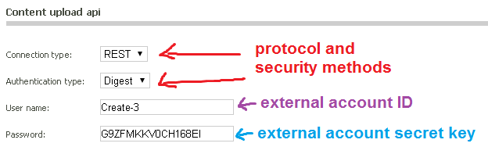

### Viewing published content in blossom

Login to blossom

Go to Content -> my content

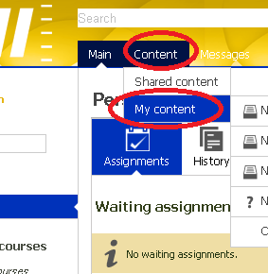

You should see the published content here:

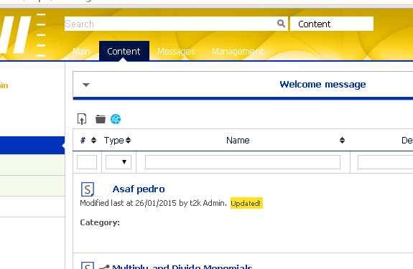

## Troubleshooting

### Errors in SSO

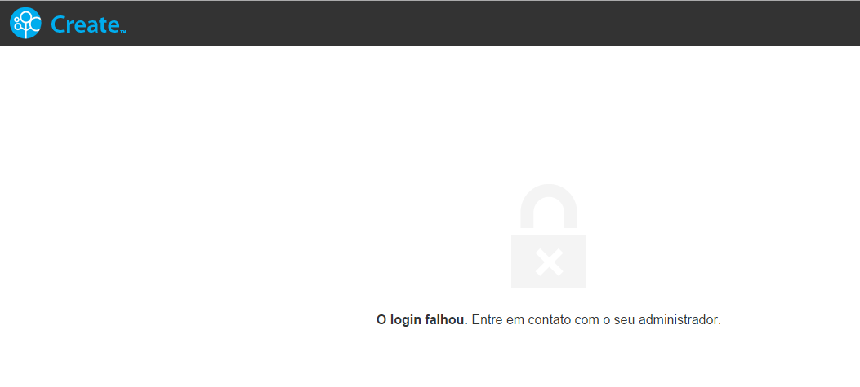

Means that one or more of the parameters of "Manage providers" are wrong.

### Errors in publish

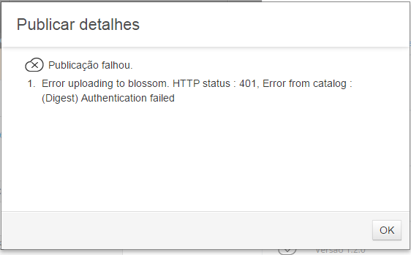

Means the one of the parameters in the content upload api is wrong